**Leaf Symmetry.**

Try to draw the other half of the leaf and then colour it so that it is the same on both sides.

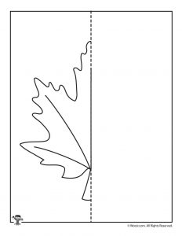

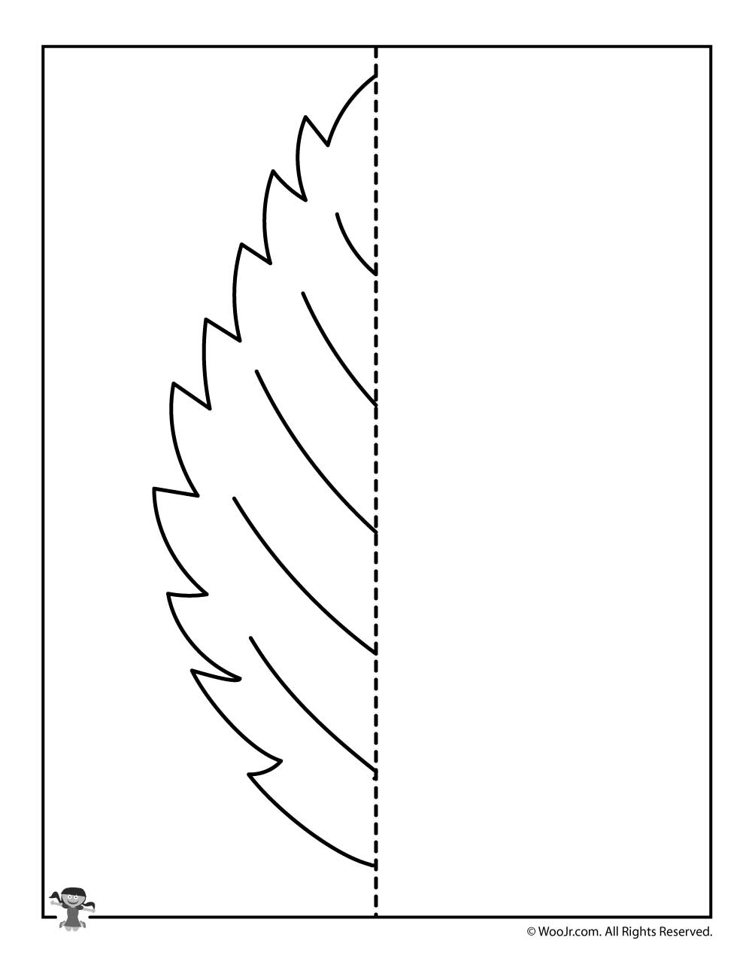

**Leaf Symmetry.**

Try to draw the other half of the leaf and then colour it so that it is the same on both sides.

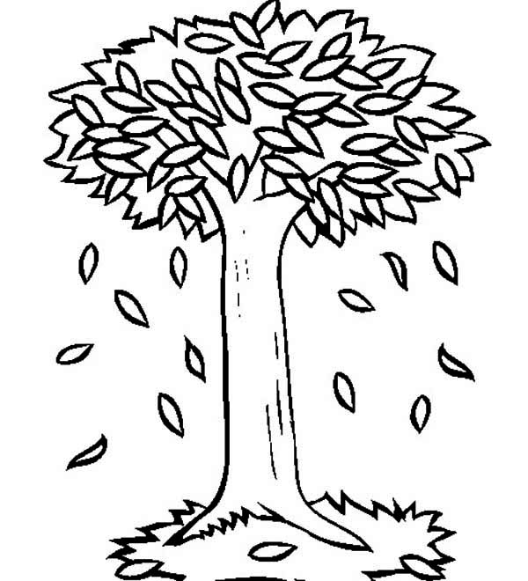

**Tree Symmetry.**

Try to draw the other half of the tree and then colour it so that it is the same on both sides.

**Tree Symmetry.**

Try to draw the other half of the tree and then colour it so that it is the same on both sides.

