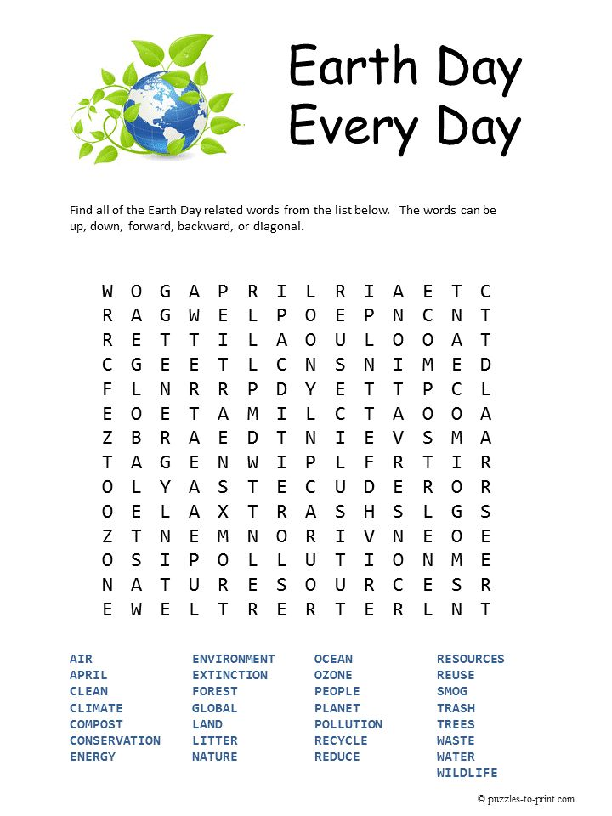

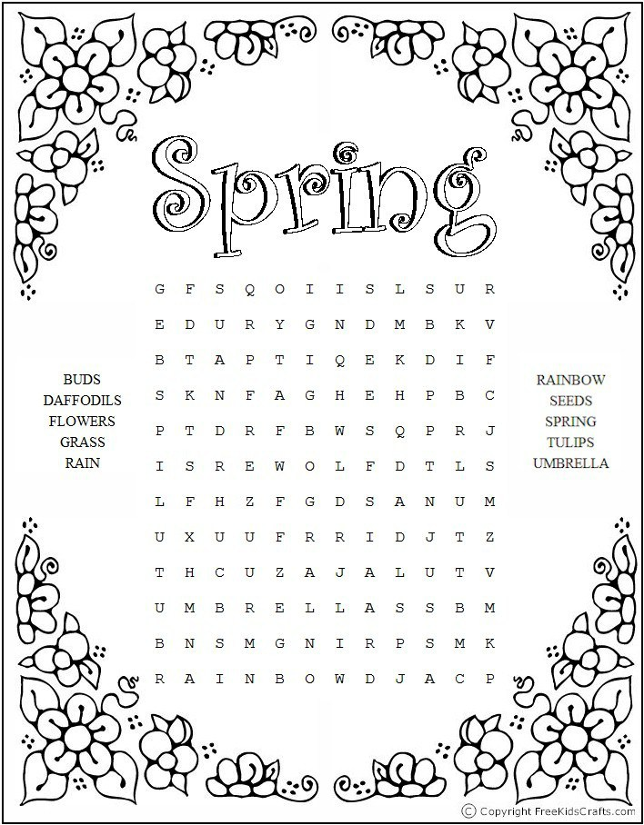

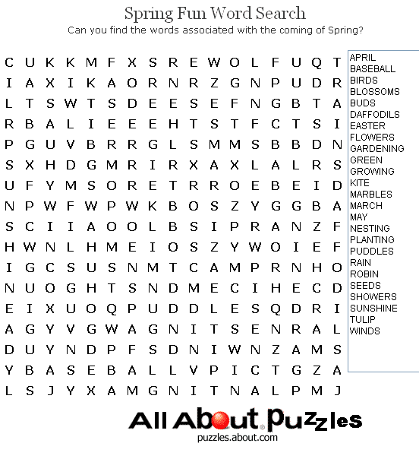

April

Birds

Blossoms

Buds

Daffodils

Flowers

Gardening

Green

Growing

May

Nesting

Planting

Puddles

Rain

Robin

Seeds

Showers

Sunshine

Tulip

Winds

**Can you find all the nature words in the wordsearch below……**

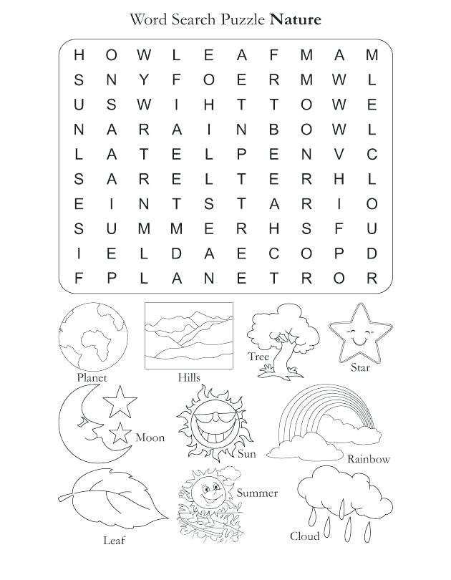

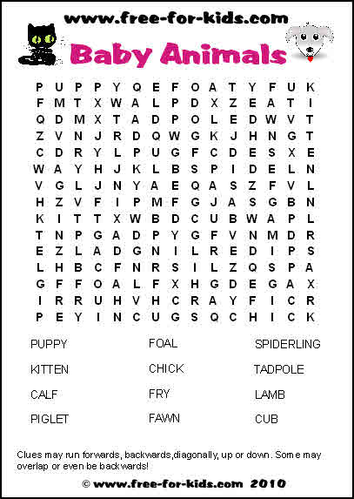

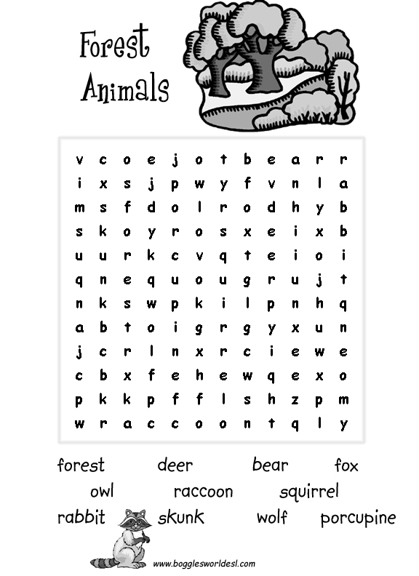

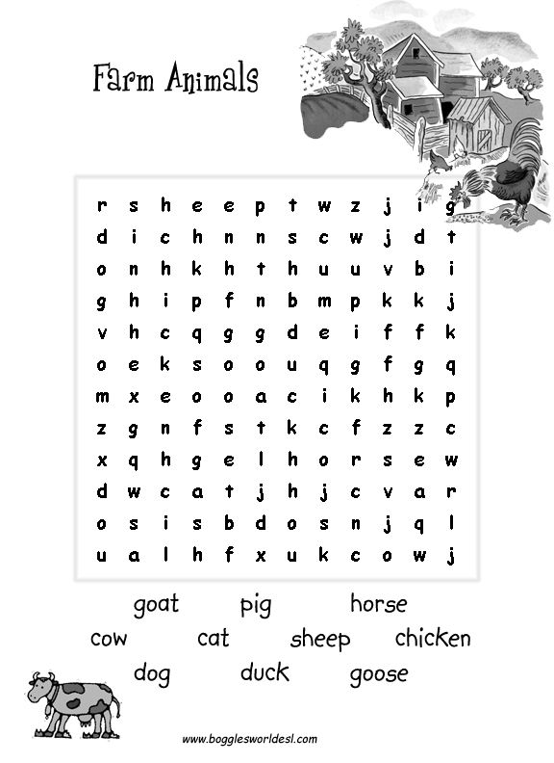

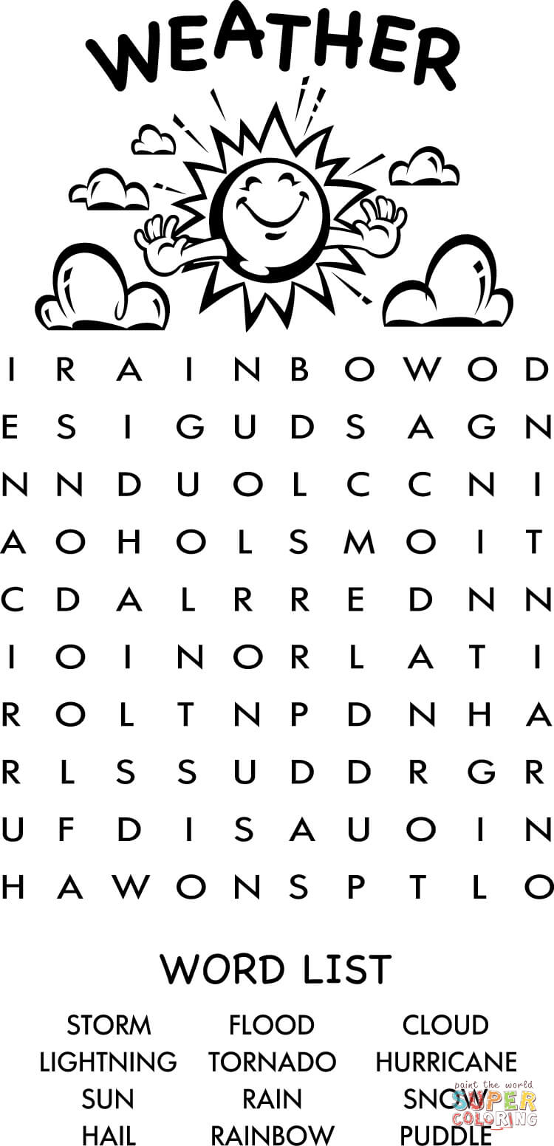

Storm Flood Cloud

Lightning Tornado Hurricane

Sun Rain Snow

Hail Rainbow Puddle

