**[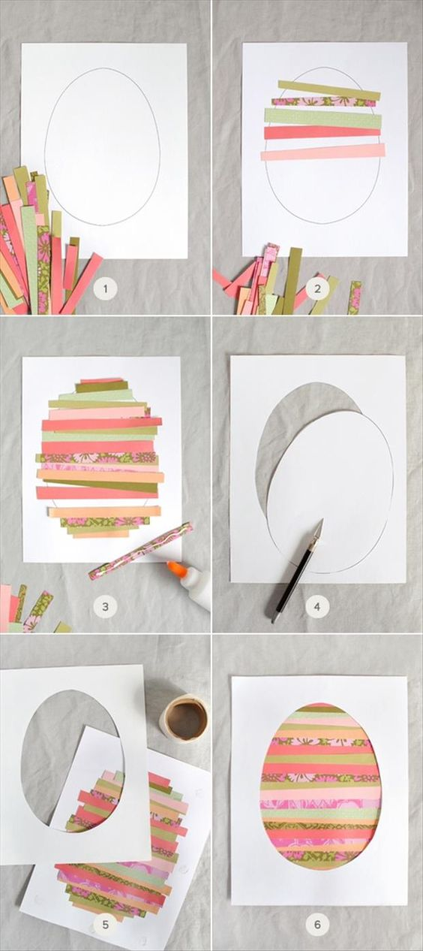](http://coolmompicks.com/blog/2013/03/27/easter-crafts-for-kids/)**

**[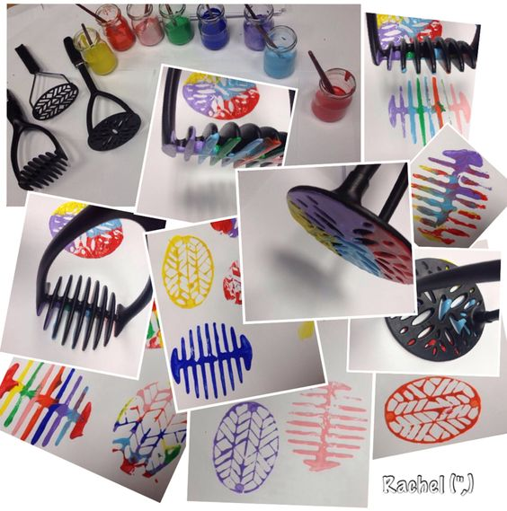](http://stimulatinglearning.co.uk/2014/03/spring-air/)**

[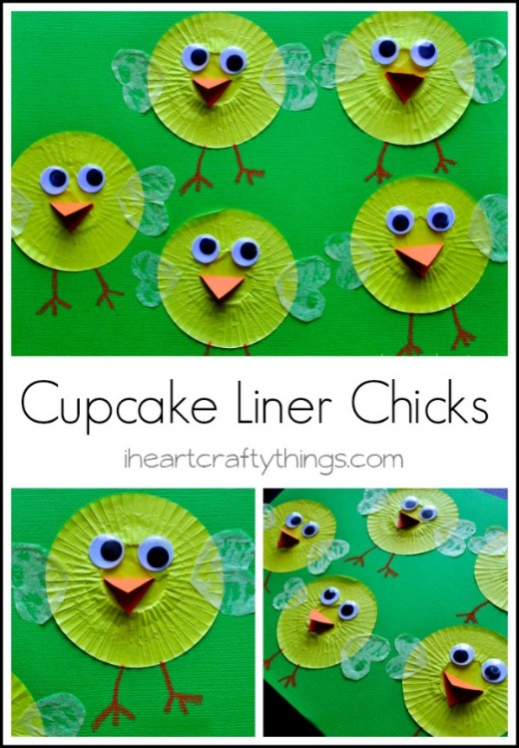](http://iheartcraftythings.com/wp-content/uploads/2013/03/CupcakeLinerChicksPin-520x750.jpg)